Document the prompt you used to generate the code
Help me complete the first phase of my semester long project full stack development project. C++ will be the programming language of choice. Give step by step instructions, including how to acquire any necessary software. My project idea is a body sculpting app that keeps track of users' workout and diet details in order to help them sculpt the body of their dreams.

Here are the assignment instructions:
CSCE 548 - Project 1
The purpose of this project is to begin creating a codebase that you will use for the rest of the semester.
Notes
The project that you will create is intended to model the type of project a professional developer would create. This assignment will create the database and data layer of the code. You are expected to create a data model that is high-caliber. The tables should have primary keys and relationships should be defined using foreign keys. There should be constraints as needed (data validation, for example). You are required to use proper relationships.
You are expected to produce a functional, bug-free application.
Tasks
Create a Github account and repository. You may use an existing account, if you have one. But create a fresh repo for this course.
Start with a problem that you want to solve or a project that you want to work on. For example, you could model the stock market, create a security vulnerability database, clone an ecommerce site, or prototype the next big delivery service. Or you can do something personal like tracking your Pokemon cards or your daily workout.
Use ChatGPT (or other AI tool including Co-Pilot/Cursor/Claude) to:
1. Create SQL scripts to generate a small database (5 tables)
a. Run those scripts on your computer to create a working instance
b. Take a screenshot of your tables as a diagram (example in the Deliverables section below)
c. Recommended: MySQL server or PostGres
2. Create SQL scripts to fill the database with test data
a. 50 rows minimum (take a screenshot to prove that there are 50+ rows)
3. Create a “data access layer” (code for objects and database interaction)
a. Any major modern language is fine. Email the instructors if you have questions
b. Include all CRUD operations
4. Create a console-based front end that can retrieve the records in the database
Test the generated code on your machine. Take screenshots to show full execution and data retrieval.
Check in that code to the Github repo you created.

You must have a minimum of 5 tables in your database. You must have at least 3 relationships between the tables (foreign keys).
Deliverables
Submit the screenshots and Github repo link to Blackboard. You can attach them to the attempt directly, or you can put them in a PDF document (NOT Word doc, Google doc, text document, or Pages doc. PDF only.)
Example database diagram: In attached image.
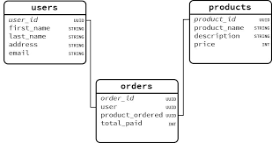
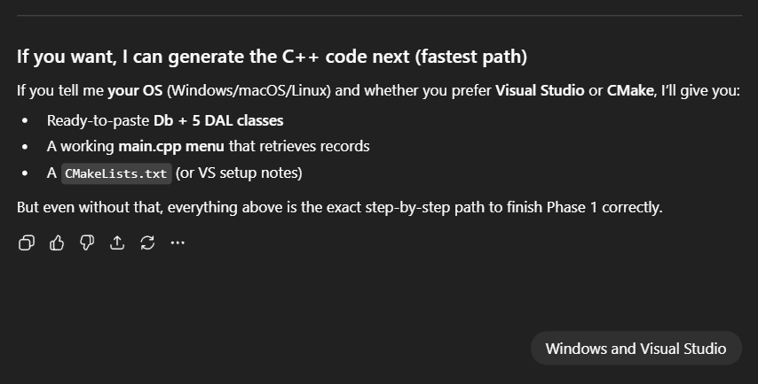
Explain what changes you made to the generated output
I updated the generated C++ code to correctly handle PostgreSQL numeric data by changing the height field from an integer to a double. I also adjusted the data access layer to use libpqxx 7+ compatible query functions and added proper error handling to prevent runtime crashes.
Analyze the effectiveness of the AI tool
The AI tool was effective at generating an initial database schema, SQL scripts, and a functional data access layer, which significantly accelerated development. It provided a strong starting point for both the database and application structure.
Did it miss anything?
The AI did not initially account for differences between PostgreSQL numeric types and C++ data types, which required manual verification of the database schema.
Were there errors you were forced to resolve?
Yes. I had to resolve type conversion errors, update deprecated libpqxx function calls, and fix include path and build configuration issues in Visual Studio to ensure successful compilation and execution.

